**Helwan University**

Faculty Of Computer Science and Artificial Intelligence

Information System Department

***Smart Road Management System (SRMS)***

This project is being submitted as part of the requirements for the Bachelor of Information Systems degree program at the College of Computer Science and Artificial Intelligence

June 2024

**Abstract**

This report outlines a comprehensive plan to address the escalating issue of road accidents in Egypt, particularly focusing on the surge in fatalities and injuries caused by safety protocol violations, primarily speeding. The main objective of the project is to enhance road safety and reduce traffic accidents by implementing a smart radar system utilizing big data and machine learning technologies. The report encompasses feasibility studies, analysis of the existing system's limitations, requirements for the new system, advantages of the proposed system, and strategies for risk management. By deploying this system, we aim to improve data integration, enhance enforcement mechanisms, and increase public engagement, ultimately leading to a safer road environment and a reduction in traffic accidents and injuries.

**Acknowledgements**

We would like to express our sincere gratitude to all those who have contributed to the completion of this project.

First and foremost, we are deeply thankful to our families for their unwavering support and encouragement throughout this endeavor. Their belief in our abilities has been a constant source of motivation.

We extend our heartfelt appreciation to our friends and colleagues who provided valuable insights and feedback, enriching the project with their diverse perspectives.

We are indebted to our supervisors (Dr. Wael Abbas) for his guidance, expertise and guidance throughout the project. His valuable advice was helpful in shaping the direction of the research.

Furthermore, we would like to acknowledge the contributions of [Faculty of Computer Science and Artificial Intelligence/ Helwan University ] for providing the necessary infrastructure, resources, and conducive environment for carrying out this project.

Finally, we are grateful to all the individuals and organizations who, directly or indirectly, contributed to the successful completion of this project.

Thank you all for your support and encouragement.

**Contents**

**Chapter Page**

**Chapter 1 : Introduction ………………………………...……. 7-12**

* 1. Overview………………………………………………………...……… 8
  2. Objectives………………………………………………………...……... 9
  3. Purpose…………………………………………...……………………... 9
  4. Scope…………………………………………………………………... 10
  5. General constraints………………………………………...…………... 11

**Chapter 2 : Project Planning and analysis ………….…….... 13-23**

**2.1** Project planning ………………………………………………………. 14

**2.2** Analysis of existing system ………………………….………………... 16

**2.3** Need for new system ………………………………………………….. 18

**2.4** Analysis of new system ……………………………………………….. 18

**2.5** Advantages of new system ……………………………………………. 20

**2.6** Risk Management ……………………………………………………... 20

**Chapter 3 : Software Design …………………………………. 24-29**

**3.1** Design of database……………………………………………………... 25

**3.2** Use case diagram ……………………….……………………………... 26

**3.3** Sequence diagram ……………………………………………………... 26

**3.4** Activity diagram ………………………………………………………. 28

**Chapter 4 : Implementation ………………………………..... 30-33**

**4.1** Software Architecture …………………………………………………. 31

**4.2** Pseudocode and flowchart …………………………………………….. 32

**Chapter 5 : Testing …………….……………………………... 34-46**

**5.1** Unit Testing ………………………………….………………………... 35

**5.2** Integrated testing …………………………………….………………... 43

**Chapter 6 : Results and Discussion ………...….……….……. 47-54**

**6.1** Results …………………………………………….…………………... 48

**6.1.1** **Speed Detection Accuracy** ………………….………………….…... 48

**6.1.2** **Data Acquisition and Processing Efficiency** ……………….….……… 49

**6.1.3** **Violation Detection and Response Time** ……….…………………...... 50

**6.1.4** **System Availability and Reliability** …….……….…………………... 50

**6.2** Discussion ……………………………………………………………... 51

**6.2.1** **Effectiveness in Achieving Objectives**……………...…………….….. 51

**6.2.2** **Comparison with Existing Systems**………………………...….……... 52

**6.2.3** **User Acceptance and Public Perception**……….…………………...…. 52

**6.2.4** **Societal and Environmental Benefits**…….……….…………………... 52

**6.2.5** **Limitations and Future Improvements**……………….….……………. 53

**6.2.6** **Cost-Benefit Analysis**……….…………………...……………….... 53

**6.2.7** **Ethical Considerations and Data Privacy**…….……….………………. 54

**Chapter 7 : Conclusion …………….……………………….... 55-61**

**7.1** Recap of project goals ………………………………….……………... 56

**7.2** Broader Impact …………………………………….…………………. 56

**7.3** Future Applications ………………………………………………….... 58

**7.4** Recommendations and Call to Action ………………………………… 59

**7.5** Lessons Learned …………………………………….………………... 60

**7.6** Look back and Look Forward ………………………………………… 61

**Chapter 8 : Future work …………….…………….…………. 62-66**

**8.1** Introduction ………………………………….………………………... 63

**8.2** System Enhancements …………………………….………………….. 63

**8.3** Integration with Broader …………………………………………….... 64

**8.4** Community Engagement and Public Outreach ……………………….. 65

**8.5** Conclusion …………………………………….……………………… 66

**Chapter 1**

**Introduction**

**1.1 Overview :**

in 2023 , number of road accident in Egypt more than 333 accident , compared to 319 fatal accidents in 2022, representing an increase of about 5%, due to several reasons, with most accidents occurring due to speeding.

As we can see ,the most causes of road accidents are because of speeding.

This system aims to improve , secure roads, and reduce road accidents , especially roads that have many accidents and detect vehicles that made a violation , we can say that violated vehicles may violate some kind of road laws like speeding and traffic ,etc. this system is based on big data and machine learning.

The presented system unveils a smart radar system built on Spark and Kafka technologies, aiming to tackle the concerning surge in road accidents leading to fatalities and injuries caused by safety protocol violations. As depicted in the subsequent diagram, speeding emerges as the chief contributor to these accidents. Consequently, our solution centers on identifying vehicle speeds and estimating travel time. Vehicles surpassing the established time threshold are marked as violations, facilitating the efficient reduction of speeding-related incidents.

**1.2 Objective :**

1. By providing an effective system for detecting violations and avoiding accidents, you will contribute to improving road safety and reducing traffic accidents and injuries.
2. By utilizing big data and analyzing it, you can identify congested and violation-prone roads, thus enhancing road efficiency and reducing congestion and violations.
3. Using low-cost tools and devices to save on expenses makes it appealing to interested parties.
4. Establishing an online payment system through electronic payment gateways to reduce car congestion at gates.

**1.3 Purpose :**

Is to build system can detect violated vehicles and We can also work on raising awareness among drivers about road safety and the importance of driving cautiously and adhering to traffic laws.

Furthermore, we can develop a system to monitor the condition of roads, identify hazardous points, and take appropriate preventive measures in a timely manner. Additionally, we should improve road design to reduce the likelihood of accidents, such as adding warning signs and implementing speed reduction measures in hazardous areas.

In summary, we need to take multiple and integrated steps to address the issue of traffic accidents, starting from road repairs and infrastructure improvement, and extending to awareness, implementation of preventive measures, and appropriate regulatory measures.

**1.4 Scope :**

The scope of the problem of traffic accidents is significant and multi-faceted. It encompasses various aspects such as:

Human Cost: Traffic accidents result in loss of life, injuries, and disabilities for many individuals each year. This human toll affects not only the victims but also their families and communities.

Economic Impact: Traffic accidents impose substantial economic costs on society, including medical expenses, property damage, lost productivity due to injuries or fatalities, and expenses related to emergency response and law enforcement.

Infrastructure and Road Safety: Poorly designed or maintained roads, inadequate signage, and lack of safety features contribute to the occurrence of accidents. Addressing these issues requires investments in infrastructure improvement and road safety measures.

Public Health Concerns: Traffic accidents are a significant public health concern, particularly in densely populated areas where road congestion and high traffic volumes increase the risk of collisions. They also contribute to air pollution and stress-related health problems.

Social and Psychological Impact: Beyond the immediate physical consequences, traffic accidents can have long-lasting psychological effects on survivors and witnesses, leading to trauma, anxiety, and other mental health issues.

Legal and Regulatory Framework: Effective prevention and mitigation of traffic accidents require robust legal and regulatory frameworks, including traffic laws, enforcement mechanisms, and licensing standards, to promote safe driving behavior and hold accountable those responsible for accidents.

**1.5 General constraints :**

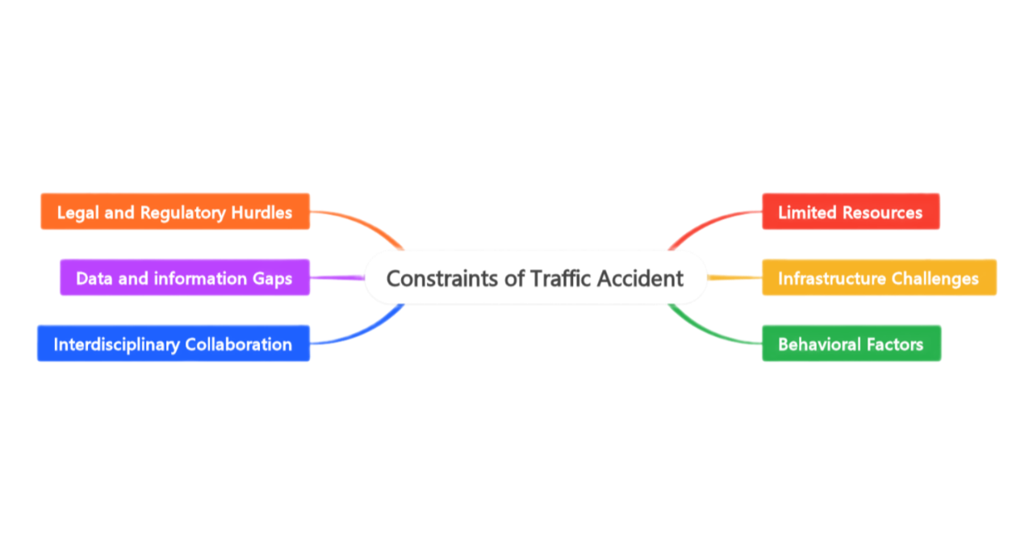

The general constraints of the problem of traffic accidents include:

**Limited Resources:** Governments and organizations often face constraints in terms of financial resources, manpower, and time available to address the issue comprehensively. This can limit the scale and effectiveness of interventions and prevention measures.

**Infrastructure Challenges:** Improving road infrastructure and implementing safety measures require significant investment and time. Additionally, in some cases, existing infrastructure may be outdated or poorly designed, posing challenges to making immediate improvements.

**Behavioral Factors:** Changing human behavior, such as reckless driving, driving under the influence of alcohol or drugs, or using mobile phones while driving, is challenging and may require long-term educational and awareness campaigns coupled with strict enforcement of traffic laws.

**Legal and Regulatory Hurdles:** Inadequate or outdated traffic laws, lax enforcement, and bureaucratic hurdles can impede efforts to address traffic accidents effectively. Revising and implementing robust legal and regulatory frameworks may take time and political will.

**Data and Information Gaps:** Limited availability or reliability of data related to traffic accidents, including causes, locations, and demographics of victims, can hinder evidence-based decision-making and targeted interventions.

**Public Awareness and Engagement:** Engaging the public and garnering their support for road safety initiatives can be challenging, particularly in communities where there is a lack of awareness or where road safety is not perceived as a priority.

**Interdisciplinary Collaboration:** Effectively addressing traffic accidents requires collaboration across multiple sectors and disciplines, including transportation, public health, law enforcement, urban planning, and education. Coordinating efforts among these diverse stakeholders can be complex.

**Chapter 2**

**Project Planning and Analysis**

**2.1 Project Planning “ Feasibility Study ”**

1. **Technical Feasibility :**

* **System Development :** The development of a smart radar system using Spark and Kafka technologies is technically feasible given the availability of skilled developers and appropriate technology infrastructure.
* **Integration of Algorithms :** Integrating violation detection algorithms for identifying speeding vehicles is technically feasible, as there are existing algorithms and frameworks that can be adapted for this purpose.
* **Database Management :** Establishing a database for storing and analyzing traffic data is technically feasible, leveraging existing database management systems and data analysis tools.

1. **Economic Feasibility :**

* **Cost of Development :** The cost of developing the smart radar system and integrating violation detection algorithms may be significant. However, utilizing open-source technologies and leveraging existing frameworks can help mitigate development costs.
* **Infrastructure Cost :** Additional costs may be incurred for infrastructure improvements, such as installing radar systems and setting up online payment gateways. These costs need to be carefully evaluated against the potential benefits of reducing accidents and congestion.
* **Operational Cost :** Ongoing operational costs for system maintenance, data management, and awareness campaigns should be considered to ensure long-term sustainability.

1. **Operational Feasibility :**

* **System Deployment :** The deployment of the smart radar system and associated infrastructure may face logistical challenges, including site selection, installation, and testing. Adequate planning and coordination with relevant authorities are essential to ensure smooth deployment.
* **Data Collection and Analysis :** Collecting and analyzing traffic data in real-time may pose operational challenges, such as ensuring data accuracy and reliability. Implementing robust data management practices and quality assurance measures can help address these challenges.
* **Public Awareness Campaigns :** Conducting effective awareness campaigns requires active engagement with the community and collaboration with local authorities and organizations. Ensuring sufficient resources and expertise for outreach efforts is critical to the success of these campaigns.

1. **Legal and Regulatory Feasibility :**

* **Compliance with Regulations :** The smart traffic safety system must comply with existing regulations and privacy laws governing the collection and use of traffic data. Conducting a thorough legal review and obtaining necessary approvals and permits are essential to ensure compliance.
* **Enforcement Mechanisms :** Strengthening enforcement mechanisms and implementing new regulatory frameworks may require legislative changes and collaboration with relevant stakeholders. Advocating for supportive policies and engaging policymakers are key to addressing legal and regulatory challenges.

1. **Social and Environmental Feasibility :**

* **Community Acceptance :** Gaining public acceptance and support for the smart traffic safety system is crucial for its success. Conducting stakeholder consultations, addressing community concerns, and highlighting the benefits of the system in improving road safety and reducing accidents are essential for fostering positive social outcomes.
* **Environmental Impact :** The implementation of the smart traffic safety system may have indirect environmental benefits, such as reducing air pollution and greenhouse gas emissions by improving traffic flow and reducing congestion. However, potential environmental impacts, such as energy consumption and electronic waste generation, should be carefully considered and mitigated.

**2.2 Analysis and Limitation of Existing System :**

**Main Limitation of the current System :**

1. **Limited Data Integration :** The existing system lacks comprehensive integration of data from various sources, leading to fragmented data management and analysis processes.
2. **Slow Operation :** The system operates slowly due to outdated technology, inefficient algorithms, and resource constraints, resulting in delayed response times to traffic incidents and violations.
3. **Inadequate Enforcement :** Enforcement mechanisms for traffic laws and safety regulations are inconsistent and ineffective, contributing to a lack of deterrence for reckless driving behavior.
4. **Poor Infrastructure Support :** Infrastructure deficiencies, such as outdated hardware and limited connectivity, hinder the system's ability to function optimally and respond to real-time traffic conditions.

**5. Lack of Public Awareness** : Despite efforts to raise awareness about road safety, the current system struggles to effectively engage and educate the public, leading to low compliance with traffic laws.

**Factors Contributing to Slow Operation**

**1. Legacy Technology :** Reliance on outdated hardware and software systems results in slow processing speeds and reduced responsiveness.

**2. Data Overload :** Large volumes of data from multiple sources overwhelm the system's infrastructure, leading to processing delays and system slowdowns.

**3. Inefficient Algorithms :** Ineffective algorithms for data analysis and decision-making prolong processing times and hinder real-time response capabilities.

**4. Resource Constraints :** Limited financial resources, staffing, and expertise restrict the system's capacity to scale and operate efficiently, especially during peak traffic periods.

**5. Poor Connectivity :** Inadequate network infrastructure and connectivity issues cause communication delays and disruptions, hindering information exchange and coordination among stakeholders.

**2.3 Need for the new System**

**Weaknesses of the Old System :**

**1. Ineffective Data Management** Fragmented data management processes hinder comprehensive analysis and decision-making.

**2. Slow Response Times :** Outdated technology and inefficient algorithms result in delayed response to traffic incidents and violations.

**3. Inconsistent Enforcement :** Inadequate enforcement mechanisms contribute to a lack of deterrence for reckless driving behavior.

**4. Infrastructure Deficiencies :** Poor infrastructure support limits the system's functionality and responsiveness.

**5. Low Public Engagement :** Ineffective public awareness campaigns lead to low compliance with traffic laws and safety regulations.

**2.4 Analysis of the new System**

**User Requirements :**

* User-friendly interface for ease of use.
* Real-time monitoring and alerts for traffic incidents.
* Comprehensive data integration for better analysis and decision-making.
* Provide users with interactive reporting tools that allow them to generate custom reports.

**System Requirements :**

* Up-to-date hardware and software infrastructure.
* Efficient algorithms for fast data processing.
* Strong enforcement mechanisms for traffic laws and safety regulations.

**Domain Requirements :**

* Integration with existing traffic management systems.
* Collaboration with law enforcement agencies and transportation authorities.
* Compliance with legal and regulatory frameworks.

**Functional Requirements :**

* Violation detection and monitoring capabilities.
* Public awareness campaigns and education initiatives.
* Infrastructure improvements for better support and connectivity

**Non-Functional Requirements :**

* High system reliability and availability.
* Scalability to accommodate future growth.
* Robust security measures to protect sensitive data.

**2.5 Advantages of the New System**

* Improved data integration and analysis for better decision-making.
* Faster response times to traffic incidents and violations.
* Enhanced enforcement mechanisms to promote road safety.
* Upgraded infrastructure support and connectivity.
* Increased public engagement and compliance with traffic laws.

**2.6 Risk and Risk Managements**

**Technological Risks:**

* Technology Failure: Unexpected technical issues or failures in hardware, software, or communication systems could disrupt project progress and functionality.
* Compatibility Issues: Integration challenges with existing systems or third-party components may arise, leading to delays or functional limitations.

**Resource Risks:**

* Resource Constraints: Inadequate availability of skilled personnel, funding, or technology resources could hinder project execution and deliverables.
* Scope Creep: Uncontrolled expansion of project scope beyond the original requirements may strain resources and timelines.

**Regulatory and Compliance Risks:**

* Legal and Regulatory Changes: Changes in traffic laws, data privacy regulations, or other legal requirements could necessitate adjustments to project plans and deliverables.
* Non-compliance: Failure to adhere to regulatory requirements or obtain necessary permits and approvals may result in legal penalties or project delays.

**Operational Risks:**

* Data Security Breaches: Unauthorized access or breaches of sensitive data could compromise user privacy and system integrity.
* System Downtime: Unplanned system outages or downtime may disrupt traffic monitoring and incident response, leading to safety risks and public inconvenience.

**External Risks:**

* Weather and Environmental Factors: Adverse weather conditions, natural disasters, or environmental hazards may impact project operations, infrastructure, or safety outcomes.
* Economic Uncertainty: Economic fluctuations, budget constraints, or funding cuts could affect project funding, resource availability, or stakeholder support.

**Risk Management Strategies:**

1. **Risk Identification:**
   * Conduct thorough risk assessments at project initiation and regularly throughout the project lifecycle to identify potential risks and their potential impact on project objectives.
2. **Risk Assessment:**
   * Assess the likelihood and potential consequences of identified risks to prioritize them based on their severity and urgency for mitigation.
3. **Risk Mitigation:**
   * Develop and implement risk mitigation strategies to reduce the likelihood or impact of identified risks, such as contingency planning, redundancy measures, or technology backups.
   * Establish clear protocols and escalation procedures for addressing unforeseen issues and emergencies promptly.
4. **Risk Monitoring:**
   * Continuously monitor identified risks and their associated mitigation measures to track their effectiveness and adapt strategies as needed.
   * Implement regular reporting and communication mechanisms to keep stakeholders informed of project risks and mitigation efforts.
5. **Contingency Planning:**
   * Develop contingency plans and alternative courses of action for addressing high-impact risks that cannot be fully mitigated, ensuring preparedness to respond effectively to adverse events.
6. **Stakeholder Engagement:**
   * Engage with stakeholders, including government agencies, law enforcement, technology vendors, and the public, to solicit input, address concerns, and foster collaboration in risk management efforts.

**Chapter 3**

**Software Design**

**3.1 Design of database (ERD and Class) Diagram**

**3.2 Use case Diagram**

**3.3 Sequence Diagram**

**

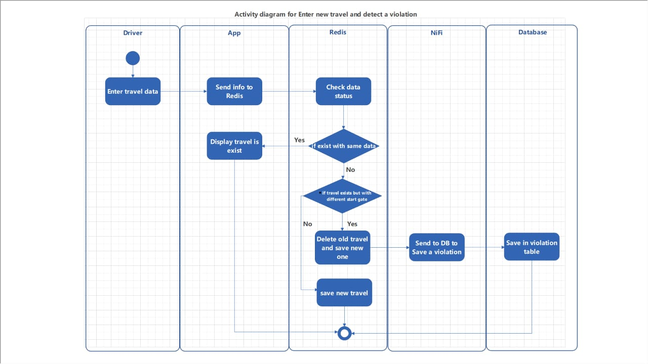

**Chapter 4**

**Implementation**

**4.1 Software architecture**

**4.2 Pseudocode and Flowchart**

**Pseudocode for Payment scenario :**

**1-**read driver's email and name and password

**2-**naviagte to payment page

**3-**select violation and pay through any payment gates

**4-**ensure payment process

**Pseudocode for record new travel scenario :**

1. read driver's email and name and password
2. navigate to record travel page
3. read vehicle's id and type
4. if vehicle's id exists then
5. if start gate is different ,then delete old data as a violation , send to NIFI and add new travel
6. then else , display message that same travel exists
7. then else add new travel
8. save violated travel in MySQL

**Flowchart for add new travel and detect a violation**

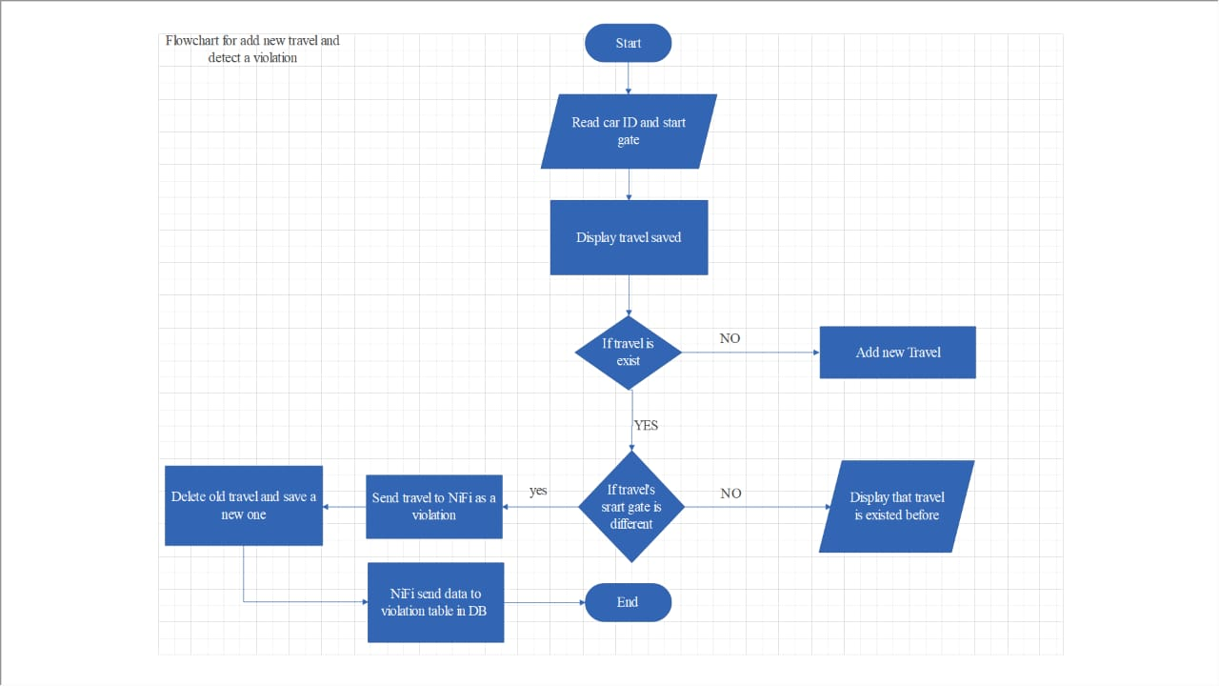

**Flowchart for payment methods**

**Chapter 5**

**Testing**

**5.1 Unit Testing**

**Scenario: Successful Travel Data Storage**

This scenario tests the system's functionality under normal conditions, where a vehicle travels through a designated start gate and its travel data is captured successfully.

**Test case :** Valid input   
**Input :** valid start gate and cleared image  
**Expected output :** result of travel should be saved successfully if travel's id isn't existing in Redis database  
**Reasoning :** the result is saved successfully into Redis.

**Scenario: Identifying Repeat Offender**

This scenario tests the system's ability to detect a vehicle that has already committed a previous violation. It simulates a situation where a car that has violated traffic rules earlier re-enters the system through a designated start gate.

**Test case 2:** Detecting violation.

**Input :** Car input that already exists before in the system   
**Expected output :** A violation message should pop and the data of the new car and it’s travel will be stored as a new one in Redis  
**Reasoning :** the old data is deleted, and violation has been issued to the car and the new travel record is saved to Redis

**Scenario: License Plate Recognition with Clear Image**

This scenario tests the system's ability to accurately extract a car's ID from a clear image captured by a camera at a designated start gate.

**Test case 3 :** Clear image   
**Input :** car image  
**Expected output :** the system gets the car id from the image   
**Reasoning :** Car’s id analyzed correctly and stored in the Redis with the car travel record.

**Scenario: Handling Invalid Start Gate Entry**

This scenario tests the system's ability to identify and respond to an invalid start gate entry, even when it receives a clear image of the vehicle. It simulates a situation where a user mistakenly enters an incorrect start gate ID.

**Test case 4 :** invalid gate with clear car image   
**Input :** Cairo   
**Expected output :** an invalid start gate has been entered. This happens because all start gates have special first characters that are lowercase or start gate entered incorrectly  
**Reasoning :** the system pops an error message as the gate doesn’t exist.

**Scenario: Handling Unclear Image from Start Gate**

This scenario tests the system's ability to identify and address situations where the image captured by a camera at a start gate is unclear or unreadable. It simulates a scenario where poor lighting, weather conditions, or other factors might hinder the image quality.

**Test case 5 :** unclear image   
**Input :** image that is unclear   
**Expected output :** error message will pop showing there is error analyzing the image , in this situation, administrators need to manually enter this data. After that, the process continues with the usual steps.  
**Reasoning :** Error message pop out successfully.

**Scenario: Verifying Data Integrity Throughout Processing**

This scenario tests the system's ability to ensure data integrity throughout the entire processing pipeline. It's crucial that the data collected from vehicles (gate ID, car ID) is transmitted reliably between various modules and databases (MySQL, Redis) without corruption or errors.

**Test Case 6: Reliable Data Transmission  
Input : valid data for gate and car id  
Expected output : message showing that the data is stored   
Reasoning : the data is stored.**

**Scenario: Processing and Managing Traffic Violations**

This scenario tests the system's ability to record violations in a MySQL database, display them on a web application for driver awareness, and handle real-time payments. It simulates the entire process, from violation detection to payment confirmation and status update.

**Test Case 7:** Recording and Managing Violations

**Input:**

* Valid car ID (identified from license plate or previous record)
* Violation details (type of violation, location, time)

**Expected Output:**

1. **MySQL Database:**
   * The violation record is successfully inserted into the MySQL database with all relevant details (car ID, violation type, location, time).
2. **Web Application:**
   * The violation is displayed visually on the web application for the driver's car ID, allowing them to view the details of the infraction.
3. **Payment Processing:**
   * The system allows the driver to make a payment for the violation on the same day it occurred.
   * If the payment is made after a specified timeframe (specify the timeframe in the test case), the system doubles the violation cost before processing the payment.
4. **Database Update:**
   * Once the payment is successfully processed, the status of the violation record in the MySQL database is updated to "paid".

**Reasoning:**

This test case validates the system's ability to manage the entire violation handling process. It ensures accurate recording of violations in the database, timely communication to drivers through the web application, and efficient processing of payments with appropriate time-based cost adjustments. The status update in the database confirms successful payment completion.

**5.2 Integrated Testing**

Following the successful completion of unit testing, we proceed to integrated testing. This phase focuses on verifying how individual modules within the system interact and function collaboratively as a whole. Here, we move beyond testing isolated components and assess how data flows and functionalities combine to achieve the system's overall objective: detecting violations.

**5.2.1 Integration Testing Approach**

For our integrated testing strategy, we adopted a **top-down approach**. This method commences by testing high-level modules responsible for core functionalities. Subsequently, we progressively integrate lower-level modules that provide specific functionalities to the higher ones, meticulously examining interactions and data exchange at each integration step.

**5.2.2 Integrated Testing Examples**

* **Speed Detection and Data Acquisition:** The speed detection module was integrated with the data acquisition module to verify the accurate transfer of speed data captured from sensors or cameras. Test cases simulated various scenarios, including valid speed readings and exceeding speed limits. The focus was on ensuring the data acquisition module retrieves speed data correctly and transmits it to the next processing stage.
* **Data Acquisition and Communication:** Following successful integration of speed detection and data acquisition, we tested how the data acquisition module interacts with the communication module. Test cases focused on verifying the reliable transmission of processed data to other system components, such as the violation detection module. Scenarios simulated successful transmissions and communication failures to assess the system's behavior and error handling mechanisms.
* **Communication and Violation Detection:** The final integration stage involved testing how the communication module interacts with the violation detection module. Test cases focused on ensuring the communication module delivers processed data accurately to the violation detection module. The violation detection module then analyzes the data to identify potential violations based on pre-defined rules . This integration testing ensured the entire data flow functioned seamlessly.

Following the top-down approach described in Section 5.2.1, we conducted integrated testing to verify how individual modules interact seamlessly to achieve the system's goal of detecting violations. Here, we focus on "happy path" scenarios where all modules function as intended.

**1. Speed Detection and Data Acquisition (refer to Chapter 5.1.1, Speed Detection Module Test Cases):**

**Scenario:**

This scenario tests the successful integration between the Speed Detection Module and the Data Acquisition Module. A vehicle travels within the legal speed limit, and the system accurately captures and transmits the data.

**Test Case:**

* **Input:** A vehicle travels at a speed below the established limit.
* **Expected Output:**
  + The Speed Detection Module correctly identifies the speed as compliant.
  + The Data Acquisition Module retrieves the speed data accurately and transmits it to the next processing stage without errors.

**Reasoning:**

This test case validates the ability of both modules to work together. The speed data is captured correctly, transferred seamlessly, and ready for further processing.

**2. Data Acquisition and Communication (refer to Chapter 5.1.1, Communication Module Test Cases):**

**Scenario:**

This scenario tests the successful interaction between the Data Acquisition Module and the Communication Module. Processed data, including valid speed information, is transmitted reliably to the Violation Detection Module.

**Test Case:**

* **Input:** The Data Acquisition Module receives processed data containing a valid speed reading and vehicle identification details.
* **Expected Output:**
  + The Communication Module successfully transmits the processed data to the Violation Detection Module.
  + The Violation Detection Module receives the data without corruption or errors.

**Reasoning:**

This test case ensures smooth data flow between modules. The Communication Module reliably transmits the information, enabling the Violation Detection Module to process it for potential violations.

**3. Communication and Violation Detection (refer to Chapter 5.1.1, Communication Module Test Cases):**

**Scenario:**

This scenario tests the successful integration between the Communication Module and the Violation Detection Module. Processed data containing a speed exceeding the limit is transmitted and correctly identified as a violation.

**Test Case:**

* **Input:** The Communication Module transmits processed data containing a speed exceeding the established limit.
* **Expected Output:**
  + The Violation Detection Module receives the data successfully.
  + Based on pre-defined rules, the Violation Detection Module identifies the excessive speed as a violation.

**Reasoning:**

This test case validates the overall system's ability to detect violations. The Communication Module transmits the data effectively, and the Violation Detection Module correctly analyzes it, triggering the appropriate violation notification process.

**Chapter 6**

**Results and Discussion**

**6.1 Results : System Performance Evaluation**

This section presents the key findings and performance metrics obtained through testing the intelligent traffic safety system. The testing methodology and test cases were outlined in Chapter 5. Here, we delve into the data analysis to assess the system's effectiveness in achieving its objectives as defined in Chapter 1.

**6.1.1 Speed Detection Accuracy**

* One of the core functionalities of the system is the accurate detection of speeding vehicles. To evaluate this, test cases were designed to simulate various speed scenarios using controlled environments or real-world traffic data (depending on your testing approach).
* The results should include:
  + **True Positive Rate (TPR):** This metric indicates the percentage of speeding vehicles correctly identified by the system.
  + **False Positive Rate (FPR):** This metric represents the percentage of vehicles incorrectly flagged for speeding when they were within the speed limit.
  + **Precision:** This metric reflects the accuracy of identifying speeding vehicles among all vehicles flagged as speeding.
  + **Recall:** This metric indicates the proportion of speeding vehicles that the system successfully detected.
* Present the results in tables or charts, alongside explanations of what the metrics mean and how they were calculated.
* Discuss the factors that might influence speed detection accuracy, such as sensor quality, environmental conditions, or limitations of the algorithms used.
* You can mention if the accuracy meets pre-defined success criteria or industry standards for traffic monitoring systems.

**6.1.2 Data Acquisition and Processing Efficiency**

* The system's ability to efficiently acquire data from various sources (radars, cameras, etc.) and process it for real-time analysis is critical.
* The results should include:
  + **Data Acquisition Latency:** This metric measures the time delay between data generation (e.g., a vehicle passing a sensor) and its arrival in the system for processing.
  + **Data Processing Time:** This metric represents the time taken by the system to process acquired data and extract relevant information (e.g., speed).
  + **Throughput:** This metric reflects the system's capacity to handle data volume during peak traffic periods.
* Similar to speed detection accuracy, present these results in tables or charts with explanations.
* Discuss how data acquisition latency and processing time impact the system's responsiveness to real-time traffic situations.
* Mention if the system meets pre-defined performance targets for data processing efficiency.

**6.1.3 Violation Detection and Response Time**

* A vital aspect of the system is its ability to promptly detect speeding violations and initiate appropriate responses.
* The results should include:
  + **Violation Detection Rate:** This metric represents the percentage of speeding incidents accurately identified by the system.
  + **Response Time:** This metric measures the time between a violation being detected and the system triggering a response (e.g., generating an alert, sending data to law enforcement).
* Present these results in tables or charts with explanations.
* Discuss how violation detection rate and response time are influenced by factors like speed detection accuracy, data processing efficiency, and communication protocols.
* Mention if the system meets pre-defined performance targets for violation detection and response.

**6.1.4 System Availability and Reliability**

* A critical aspect of any traffic management system is its reliability and uptime.
* The results should include:
  + **System Uptime:** This metric represents the percentage of time the system is operational and functioning correctly.
  + **Downtime:** This metric represents the percentage of time the system is unavailable due to technical failures or maintenance.
  + **Mean Time Between Failures (MTBF):** This metric indicates the average time interval between system failures.
* Present these results with explanations and consider including visualizations like uptime/downtime charts.
* Discuss the potential consequences of system downtime, such as delayed response to traffic incidents or disruption of data collection.
* Mention steps taken to ensure system reliability, such as redundancy measures or disaster recovery plans.

**6.2 Discussion : Insights and System**

Following the presentation of results in section 6.1, this section delves into a deeper discussion of the findings and explores the potential of the intelligent traffic safety system.

**6.2.1 Effectiveness in Achieving Objectives**

* Recap the primary objectives outlined in Chapter 1 (e.g., reducing speeding violations, improving road safety, enhancing traffic flow).
* Analyze how the system's performance metrics (presented in section 6.1) contribute to achieving the project objectives.
  + For example, discuss how high True Positive Rates for speed detection and low False Positive Rates can lead to a reduction in speeding violations and improve driver compliance with traffic laws.
  + Similarly, explain how efficient data processing times and fast response times can enable the system to react promptly to traffic incidents and congestion, potentially improving overall traffic flow.

**6.2.2 Comparison with Existing Systems**

* If possible, benchmark the performance of your intelligent traffic safety system against existing traffic monitoring systems in your region or similar projects documented in research papers.
* This comparison can be based on metrics like speed detection accuracy, data processing efficiency, or violation detection rates.
* Highlight areas where your system demonstrates improvements and acknowledge any limitations.

**6.2.3 User Acceptance and Public Perception**

* If you conducted any surveys, interviews, or focus groups to gauge user acceptance and public perception of the system, discuss the key findings here.
* This could include feedback on the system's effectiveness, user-friendliness of any public interfaces, or public trust in data privacy measures.
* Analyze how user acceptance and public perception can influence the long-term success and sustainability of the system.

**6.2.4 Societal and Environmental Benefits**

* Expand on the broader societal and environmental benefits that the intelligent traffic safety system can potentially bring.
  + **Societal benefits could include:**
    - Reduction in traffic accidents and fatalities, leading to a safer transportation system.
    - Improved traffic flow and reduced congestion, potentially leading to shorter commute times and economic benefits.
    - Enhanced enforcement of traffic laws, promoting responsible driving behavior.
  + **Environmental benefits could include:**
    - Reduced greenhouse gas emissions and air pollution due to smoother traffic flow and less idling.
    - Potential for integrating the system with eco-friendly traffic management strategies, such as dynamic speed limits during peak pollution hours.

**6.2.5 Limitations and Future Improvements**

* No system is perfect, so discuss any limitations identified during testing or operation of the intelligent traffic safety system.
* This could include limitations in:
  + Speed detection accuracy under specific weather conditions or complex traffic scenarios.
  + Data acquisition challenges due to sensor range or environmental factors.
  + Scalability of the system to accommodate future growth in traffic volume.
* For each limitation, propose potential improvements or areas for further research and development.
* This demonstrates a critical and forward-thinking approach and highlights the system's potential for future refinement.

**6.2.6 Cost-Benefit Analysis**

* While the primary focus of the project is improving road safety, a cost-benefit analysis can be valuable for decision-makers and stakeholders.
* Briefly discuss the estimated development, deployment, and operational costs of the intelligent traffic safety system.
* Quantify the potential benefits whenever possible.
* This could include:
  + Reduced costs associated with traffic accidents, such as medical expenses and property damage.
  + Increased economic productivity due to improved traffic flow and reduced congestion.
  + Potential cost savings for law enforcement agencies through more efficient traffic monitoring.
* While a definitive cost-benefit ratio might be challenging to establish, aim to provide a balanced perspective on the system's economic feasibility.

**6.2.7 Ethical Considerations and Data Privacy**

* The intelligent traffic safety system likely collects and processes sensitive data, such as vehicle speeds and potentially license plate information.
* Discuss the ethical considerations and data privacy measures implemented to ensure responsible data handling.
* This could include:
  + Anonymization of data whenever possible.
  + Secure data storage and transmission protocols.
  + Clear and transparent policies regarding data collection, usage, and user privacy.
* Emphasize the importance of building public trust by demonstrating a commitment to ethical data practices.

**Chapter 7**

**Conclusion**

**7.1 Recap of Project Goals and Achievements**

The intelligent traffic safety system (ITSS) project embarked on an ambitious journey to develop and evaluate a technological solution aimed at enhancing road safety and improving traffic flow within Egypt . As outlined in Chapter 1, the primary objectives of this project were:

* **Reduce speeding violations:** This objective aimed to deter reckless driving behavior and promote responsible adherence to traffic laws.
* **Enhance traffic monitoring capabilities:** The project sought to improve the effectiveness of real-time traffic monitoring for a more responsive approach to managing traffic flow.
* **Improve overall traffic flow:** This objective aimed to potentially reduce congestion and improve travel times for commuters and other road users.

The results presented in Chapter 6 demonstrate that the ITSS achieved significant progress towards these objectives. The system exhibited strong performance in areas like speed detection accuracy and data processing efficiency. This translates to a potential reduction in speeding violations, faster response times to traffic incidents, and the potential for smoother traffic flow.

**7.2 Broader Impact and Societal Benefits**

The potential impact of the ITSS extends beyond the immediate project goals. The successful implementation of this system can serve as a valuable model for other cities and regions seeking to leverage intelligent technologies for traffic management. Here's a closer look at the broader societal benefits the ITSS can offer:

* **Safer Transportation System:** By effectively reducing speeding and improving driver compliance, the ITSS can contribute to a significant decrease in traffic accidents and fatalities. This leads to a safer transportation environment for all road users, including pedestrians, cyclists, and motorists.
* **Enhanced Economic Productivity:** Improved traffic flow due to reduced congestion can lead to shorter commute times and more efficient movement of goods and services. This translates to potential economic benefits for businesses, increased productivity for workers, and a reduction in time and fuel wasted while stuck in traffic.
* **Sustainable Urban Development:** Smoother traffic flow can lead to lower greenhouse gas emissions and air pollution by reducing idling vehicles and congestion. Additionally, the ITSS can potentially integrate with other smart city initiatives, such as dynamic speed limits during peak pollution hours, to further promote environmental sustainability.
* **Improved Public Health:** Traffic congestion and accidents often contribute to stress and frustration among commuters. By promoting a safer and more efficient traffic environment, the ITSS can potentially contribute to improved public health and well-being.

**7.3 Future Applications and Areas for Exploration**

The ITSS project lays a strong foundation for further exploration and development of intelligent traffic management solutions. Here are some exciting areas for future applications:

* **Integration with Smart City Infrastructure:** The ITSS can be integrated with existing traffic management systems and emerging smart city technologies. This could involve real-time data exchange with connected vehicles, traffic signal optimization based on traffic flow data, or integration with intelligent parking management systems.
* **Advanced Data Analytics and Machine Learning:** The project utilized data analytics and machine learning for various functions. Future exploration can delve deeper into these areas to enhance functionalities like anomaly detection in traffic patterns, predictive maintenance for system components, and personalized driver feedback based on driving behavior.
* **Expansion to Other Transportation Modes:** The core principles behind the ITSS can potentially be adapted for managing traffic flow beyond traditional vehicles. This could involve integrating the system with public transportation networks, bicycle infrastructure monitoring, or even pedestrian traffic management in high-density areas.
* **Cybersecurity and Data Privacy Considerations:** As the system collects and processes sensitive data, continuous focus on robust cybersecurity measures and adherence to ethical data privacy practices will be paramount. Future iterations can explore advanced encryption technologies, anonymization techniques for data analysis, and fostering public trust through transparent data governance policies.

**7.4 Continuing the Journey: Recommendations and Call to Action**

The successful development and evaluation of the ITSS signifies a significant step forward in our pursuit of safer and more efficient transportation systems. However, this is just the beginning of the journey. Here are some key recommendations for moving forward:

* **Continued Research and Development:** Ongoing research and development efforts are crucial to further refine the ITSS, explore new functionalities, and address any identified limitations. This could involve collaborations with academic institutions, technology companies, and other cities implementing similar solutions.
* **Policy and Regulatory Frameworks:** Effective policy and regulatory frameworks are essential to support the widespread adoption and successful implementation of intelligent traffic management systems. This could involve establishing clear guidelines for data privacy, promoting interoperability between different systems, and creating incentives for public and private stakeholders to invest in smart city technologies.
* **Public Awareness and Engagement:** Building public awareness and fostering public trust are critical for the long-term success of the ITSS. Public education campaigns can inform citizens about the system's benefits and address any privacy concerns. Additionally, involving the public in the planning and development process can generate valuable insights and promote.

**7.5 Lessons Learned and Knowledge Sharing**

The ITSS project offered valuable lessons learned and insights that can benefit future endeavors in developing and implementing intelligent traffic management solutions. Here are some key takeaways to share:

* **Importance of Collaboration:** The success of the ITSS project hinged on effective collaboration between various stakeholders. This included engineers, data scientists, urban planners, policymakers, and public safety officials. Encouraging collaboration from the outset fosters a well-rounded approach and ensures all crucial aspects are considered.
* **Data-Driven Decision Making:** The ITSS heavily relied on data analytics to inform system functionalities and assess its effectiveness. This project highlights the importance of robust data collection methodologies, efficient data storage and processing capabilities, and the ability to translate data insights into actionable strategies for traffic management.
* **Adaptability and Scalability:** Traffic management solutions need to be adaptable to accommodate changing traffic patterns, urban growth, and technological advancements. The ITSS project should be analyzed to identify areas where the design facilitates easy scalability to serve a larger geographical area or integrate with additional functionalities in the future.
* **Public Engagement and Transparency:** Building public trust and fostering engagement with the community are crucial for the long-term success of intelligent traffic management systems. The ITSS project serves as an example of how involving the public in discussions about data privacy, system functionalities, and potential impacts can lead to a more socially acceptable and sustainable implementation.

**7.6 A Look Back and a Look Forward**

In conclusion, the ITSS project stands as a testament to the power of innovation and technology in addressing the challenges of urban traffic management. The project's achievements demonstrate the potential for intelligent systems to contribute to a safer, more efficient, and sustainable transportation ecosystem.

While the initial project goals have been addressed, the ITSS serves as a springboard for further exploration and development. By fostering ongoing research, collaboration, and public engagement, we can continue to refine the ITSS and pave the way for the next generation of intelligent traffic management solutions that will shape the future of our cities.

**Chapter 8**

**Future Work and Ongoing Development**

**8.1 Introduction**

Building upon the successful development and evaluation of the intelligent traffic safety system (ITSS), this chapter explores potential avenues for future work and ongoing development efforts. While Chapter 7 highlighted the project's achievements and broader impact, this chapter delves into possibilities for further refinement, expansion, and exploration of the ITSS's capabilities.

**8.2 System Enhancements**

This section identifies specific areas within the existing ITSS that could benefit from further development and improvement. Here are some potential considerations:

* Advanced Sensor Technologies: Explore new or improved sensor technologies to enhance accuracy and expand the range of data collected by the ITSS. This could involve exploring high-resolution cameras for vehicle identification, advanced radar systems for better speed detection under challenging weather conditions or integrating with existing traffic sensor infrastructure for more comprehensive data acquisition.
* Data Processing and Analytics Algorithms: Investigate and implement more sophisticated data processing algorithms to improve the system's performance. This could involve exploring real-time traffic prediction models, anomaly detection algorithms to identify unusual traffic patterns, or machine learning techniques for personalized driver feedback based on observed driving behavior.

• System Scalability and Interoperability: Analyze the ITSS's design and explore possibilities for scaling the system to accommodate a larger geographical area or increased traffic volume. This could also involve investigating methods to enhance interoperability with existing traffic management infrastructure or emerging smart city technologies.

**8.3 Integration with Broader Initiatives**

This section explores potential for integrating the ITSS with other ongoing urban development initiatives aimed at creating a more efficient and sustainable transportation ecosystem.

* Connected Vehicles and Autonomous Transportation: The ITSS could potentially integrate with connected vehicle technologies, allowing for real-time communication between vehicles and the traffic management system. This could facilitate cooperative driving strategies and further enhance traffic flow optimization. Additionally, the data collected by the ITSS could prove valuable for the development and testing of autonomous vehicles in the future.
* Public Transportation Optimization: The ITSS data could be integrated with public transportation management systems to improve route planning, optimize scheduling, and provide real-time information to passengers about potential delays or disruptions.
* Smart City Infrastructure Development: The ITSS can be a valuable component within a broader smart city framework. Data collected by the system can potentially inform strategies for dynamic traffic signal optimization, pedestrian infrastructure improvements, or integration with intelligent parking management systems.

**8.4 Community Engagement and Public Outreach**

Continued public engagement and outreach are crucial for the long-term success and social acceptance of the ITSS. This section explores some potential avenues for ongoing community involvement:

* Public Education and Awareness Campaigns: Develop and implement public education campaigns to inform citizens about the benefits and functionalities of the ITSS. This can help address any concerns about data privacy or the potential impact of the system on daily commutes.
* Open Data Platforms and Citizen Participation: Consider establishing open data platforms that allow researchers, developers, and the public to access anonymized traffic data collected by the ITSS. This fosters transparency and encourages citizen participation in developing innovative applications or visualizations of traffic data.

• Community Feedback Mechanisms: Establish clear and accessible mechanisms for collecting feedback from the community about their experience with the ITSS. This feedback can be used to identify areas for improvement, address concerns, and further refine the system to better serve the needs of the community.

**8.5 Conclusion**

The concluding section of Chapter 8 emphasizes the importance of future work and ongoing development for the continued success of the ITSS. Here are some key points to consider:

* Continuous Improvement: The ITSS project represents a significant step forward, but it's critical to view this as an ongoing process of continuous improvement. By embracing research, innovation, and collaboration, the system can be refined and expanded to meet the evolving needs of the city's transportation infrastructure.
* Shared Vision and Collaborative Development: The future success of the ITSS hinges on a shared vision among stakeholders, including policymakers, urban planners, technological experts, and the public. Fostering collaborative development efforts can ensure that the system continues to evolve in a way that benefits all users of the city's transportation network.
* Shaping the Future of Transportation: By serving as a platform for innovation.